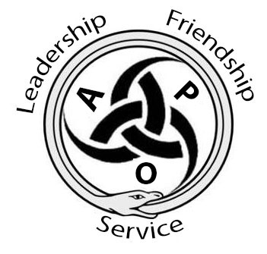

ALPHA PHI OMEGA
Section 94/96 Conclave
“Myths and Legends”
March 20th-22nd, 2015
Hosted by the Omicron Iota Chapter

Greetings My Fellow Brethren!

Light up your torches, gather all your weapons, and march your way down to Worcester Polytechnic Institute this MARCH (20th-22nd). The Omicron Iota Chapter at WPI is thrilled to host this gathering of Section 94 and 96 for the Spring 2015 Conclave!

The theme will be “Myths and Legends” so be prepared to go back and relive this legendary era with a weekend full of leadership, friendship, and service!

Early Registration for Conclave will be $40, which covers conference and banquet fees. This Early registration deadline will be February 27th, and late registration after that will be $45! The Absolute Final date to register if you want a seat at the banquet and all the treasures included with registration is March 6th! There is a conclave shirt for this event that is available for purchase at an additional cost of $8 per person.

Lunch will be on your own, but we do have a variety of restaurants within walking distance/short drive including our Campus Center, Boynton Restaurant, Moe’s Southwest Grille, Thai Time, and Subway. A more detailed list with addresses will be provided when you pick up your registration packet. Banquet dress will be semi-formal or you may dress in your best mythological and god-like attire!

This packet includes an overview of service and fellowship events, directions/map to campus, and hotel options. You can also visit our website by clicking here. Feel free to send any questions or concerns you might have to our conclave chair, Kyle Peffer, at apo-conclave@wpi.edu. For all of you social media lovers, #WPIConclave15 is the official hashtag for the weekend to use and share on your app of choice.

Remember to submit your registration by FEBRUARY 27TH to qualify for the early bird registration!

Yours in Leadership, Friendship, and Service/
The Omicron Iota Chapter
Service:
We will be hosting a FOOD DRIVE in which we will be collecting canned goods as well as those without preservatives. Some examples of items that we will need are canned vegetables, pasta, soups, crackers, boxed side dishes, etc. So bring all the food you can and help those in need! In addition, during Conclave, we will host a service project in which we will collect goods from the surrounding neighborhoods.
Finally, we will have some fun CLEARING TRAILS at Newton Hill! Located just a short walk away from campus across from Elm Park, there is a beautiful wooded trail that needs some love! So come on over and grab a rake and participate in a fun outdoor service with your favorite people! Rake and work gloves will be provided. Make sure to dress warmly!
Fellowship:
While APO is largely centered on community service, it is always important that we have loads of fun. Come join us for some fantastic fellowships! Starting off the fun, we have a PAJAMA PARTY MOVIE NIGHT for all of you on Friday! As awesome as movies are, what better way to enjoy a movie then with some sort of sugary foods? But wait! All that sugary food is going to need to be worked off somehow…
Join us Saturday where we have a BALLROOM DANCE LESSON planned for all of you before the banquet. Come learn (or help teach!) how to dance so we can all look super snazzy on that dance floor!
We are also recreating the game show LEGENDS OF THE HIDDEN TEMPLE on the WPI campus! So get your best warriors together and get pumped for a terrific conclave! If you have never seen Legends of the Hidden Temple, take a thirty minute break from being an adult and watch the first episode here: https://www.youtube.com/watch?v=8_HXmQX5_tU

Leadership:
We are offering APO LEADS courses at conclave! Currently, we will be offering Launch and Discover. We may add additional courses, but we will be sure to inform you of any changes! These courses are first come, first serve. Additionally, these courses may be cancelled if the minimum enrollment is not reached. If you desire a Sunday Explore class, go to the website and vote on the poll! If enough people want it, we can host one!

LAUNCH:
This course focuses on explaining exactly what it is that makes chapters' leadership effective and covers the differences between the traditional notion of leadership and the evolving concept of servant leadership.
Objectives:
• Increase the participants' knowledge of leadership skills and principles.
• Understand and utilize the principles of Servant Leadership and understand how it applies to Alpha Phi Omega.
• Provide active strategies that participants can use in their chapter.
• Increase participants' awareness of leadership opportunities in Alpha Phi Omega.
DISCOVER:
In this course, attendees will learn strategies for assertive communication and self-motivation within the context of the servant chapter model.
Objectives:
• To understand social interaction styles of yourself and others and their effects on relationships.
• To provide assertiveness skills that will help you be a better individual, brother, leader and team member.
• To identify motivating factors that will enable you to be the most effective and efficient in what you want to do.

Registration Checklist:
- Gather Information From Your Chapter
  - Ask the members of your chapter who will be interested in attending, what (if any) APO LEADS course they would like to attend, and if anyone is interested in buying a Conclave t-shirt (additional $8), what size they would like. We will be asking for general contact information for all attendees as well.
  - For Banquet, We will be having a Mixed Grill Dinner Buffet! This means that you get three smaller portions of entrees. Options include: Balsamic Marinated Portobello Mushrooms, Au Poivre Beef Tenderloin, and Grilled Raspberry Ducking Breast. There will also be Caesar Salad, Roasted Garlic Smashed Potatoes with Caramelized Onions, and Maple Glazed Carrots. For dessert there will be a Brownie Bar, including Blondies, Peppermint, M&M, and Chocolate Brownies.
- Fill Out PAPER Registration Form
  - For this Conclave, there will be only paper registration and payment. If for any reason you are having trouble sending in the documents or payment, feel free to contact us at apo-conclave@wpi.edu. Remember, for EARLY registration, we must have RECEIVED all the materials by February 27th! Then, FINAL ABSOLUTE Registration Deadline for RECEIVING all materials is March 6th! If the postmark date is later than each of these, you/your chapter is subject to late fees, loss of souvenir glassware, loss of T-shirts, and inability to save a place for you at banquet. Keep this in mind!
- Mail All Required Documents by March 6th!
  - Please mail the registration form and payment (made out to ALPHA PHI OMEGA- OMICRON IOTA CHAPTER) to:
Alpha Phi Omega, Omicron Iota Chapter
c/o Student Activities Office
100 Institute Road,
Worcester, MA, 01609

- Register for Hotel Rooms! Cutoff Date for the Group Rate is FEBRUARY 27th!
  - We have secured a group rate for Conclave at the Hilton Garden Inn, about ¾ a mile from campus. Details are in the Hotel Information Section below. Make sure that all reservations are taken care of before February 27th if you want the group rate!
Attendee Registration:
Shirt Size: S, M, L, XL, XXL, or leave blank for none. Remember each shirt is $8
Type: Please Indicate (PL)edge, (A)ctive, (PE)titioner, (S)taff, (AD)visor, (AL)umni, or (G)uest for each attendee.
Dietary Restrictions: Please note any food allergies or sensitivities (including vegetarian/vegan). We will work with the catering company to make sure that everyone has a meal they can eat at banquet.
APO LEADS course: Please indicate which (if any) APO LEADS course that each attendee would like to take – (L)aunch or (D)iscover. Leave blank if they do not wish to take an APO LEADS course. Note that Launch is a prerequisite for Discover. These courses are first come, first serve. Once the course is full, we will not be able to accommodate any additional attendees. Additionally, the courses may be cancelled if minimum enrollment is not reached. These courses are at the same time, so please do not register for both.
Name | Type | Shirt Size | Dietary Restrictions | APO LEADS Course

Registration Form:

CHAPTER: _______________________________________________
SCHOOL: ________________________________________________
Designate the contact person for your chapter. They should be attending conclave. We will send any important updates and confirmations to them, as well as requests for additional information, if necessary.

CONTACT PERSON: __________________________________________
CONTACT PERSON EMAIL: ____________________________________
CONTACT CELL PHONE: _______________________________________
In-person registration will be open starting at 7 pm to 11 pm on Friday night, and for an hour before the opening ceremony on Saturday morning. There will be registration tables located in Salisbury Labs where all the workshops will be located
Registration costs will be $40 per person and t-shirts will cost $8 each (unisex sizes S,
M, L, XL and XXL).

REGISTRATION: __________ x $40 = $_______________ _________x$45 = $__________
T-SHIRTS: __________ x $8 = $_______________
TOTAL: ___________
Please make any check payments payable to The Omicron Iota Chapter of Alpha Phi
Omega and mail them to the address below. Payment must be received by March 6th!
In the memo area please make note of your chapter name and if paying for multiple people please jot a note of the attendees you are paying for.
Alpha Phi Omega, Omicron Iota Chapter
c/o Student Activities Office
100 Institute Road
Worcester, MA, 01609
Directions to campus
Campus Address: 100 Institute Road, Worcester MA, 01609

From the East
Take Mass. Turnpike (I-90) to Exit 11A (I-495). Proceed north to exit 25B (I-290), then west into Worcester. Take Exit 18(Lincoln Sq., Rte. 9), turn right at end of ramp, then an immediate right before next traffic light. At next light, proceed straight through, bearing to the right on Salisbury St.* At the WPI sign, turn left onto Boynton St., then right onto Institute Rd. Take your first right (Private Way). Head to Salisbury Laboratories after parking.
From the North
Take I-495 south to I-290. Follow directions from east. Head to Salisbury Laboratories after parking.
From the South and West
Take Mass. Turnpike (I-90) to Exit 10 (Auburn). Proceed east on I-290 into Worcester. Take Exit 17(Lincoln Sq., Rte. 9), turn left at end of ramp, follow Rte. 9 west through Lincoln Sq., straight onto Highland St.,** then right at light onto West St. Travel one block and cross Institute Road (onto Private Way). Head to Salisbury Laboratories after parking.
We are currently unaware of where people will be able to park. You can follow THIS link to a map of the on campus parking areas. The areas in blue are designated for visitors, so expect to park there. The parking garage is also open to visitors, and will most-likely be the place for you to park. All of these spaces require a parking permit, which will be available to you when you arrive. You can access the parking garage from the driveway of the First Baptist Church on Salisbury Street. The address is 111 Park Avenue, Worcester MA.
There will be brothers around campus that will be more than happy to direct you to wherever you need to go. Our campus is fairly small, and nothing will be at the more outlying part of the campus (Gateway).

Hotel Information
Our Reserved Hotel:
Hilton Garden Inn 35 Major Taylor Blvd
Distance to Campus: 0.8 miles Worcester, MA 01608
Rate: $124.00/Night
USE CODE TO GET GROUP RATE: APOC15
The Hilton Garden Inn is offering complimentary parking for this event.
To use our group rate, please reserve your room by 2/27/2015.
Other Nearby hotels:
Courtyard Marriot Worcester
72 Grove Street, Worcester, MA, 01605
Distance to Campus: 0.4 miles
Holiday Inn Express Worcester
110 Summer Street, Worcester, MA, 01608
Distance to Campus: 1.2 miles
Beechwood Hotel
363 Plantation Street, Worcester, MA, 01605
Distance to Campus: 2.8 miles
Residence Inn Worcester
503 Plantation Street, Worcester, MA, 01605
Distance to Campus: 3.9 miles

Salisbury Laboratories

Parking Garage
Campus Center

T-SHIRT!
Front
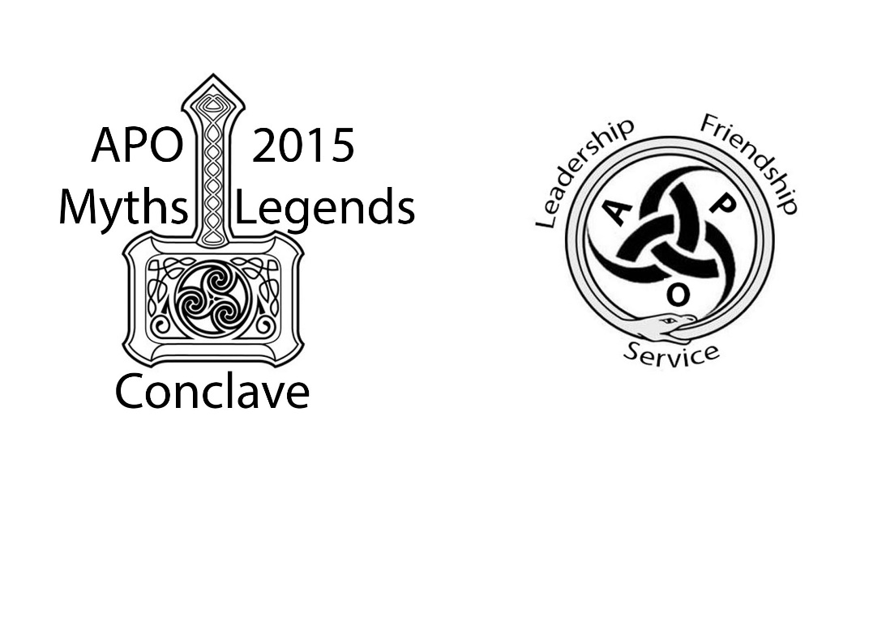
Back
